Name: Chimzim Ogbondah
Section: 9
University ID: 273362113

Cpr E 308 Lab 3 Report

Summary (20 pts):
Through this lab I was able to learn about how to create a thread/multiple threads and having them finish running. This taught me about pthread_create() and pthread_join(). I also got to learn about synchronizing threads by messing with mutexes (locking and unlocking) and then learning how to use conditional variables and waiting. (you can use the conditional variable to signal when an operation is done…and then use that as the parameter for the wait() so the next thing waits for the prior thing to be done). Finally I was able to learn more about the producer consumer problem and be able to create my own producer from the knowledge learned on conditional variables and waiting and then the idea of mutexes with locking and unlocking.

Lab Questions:
3.1:
10 pts Add a sleep(5) statement in the beginning of both thread1 and thread2. Compile and run the program. Do the messages get printed? Why or why not?
No, the messages do not print out. They don’t print out because we cause both threads to sleep and during that time Main will finish its execution since we still have not joined the threads it won’t wait for the threads to finish running

5 pts Add two pthread_join() calls to join t1 and t2 just before the print statement in main(). Compile and run the program. Do the threads' messages get printed? Why or why not?
The thread messages to get printed because the pthread_join waits for the thread to terminate before moving on.

5 pts Include your code with comments explaining the usage of pthread_create() and pthread_join().
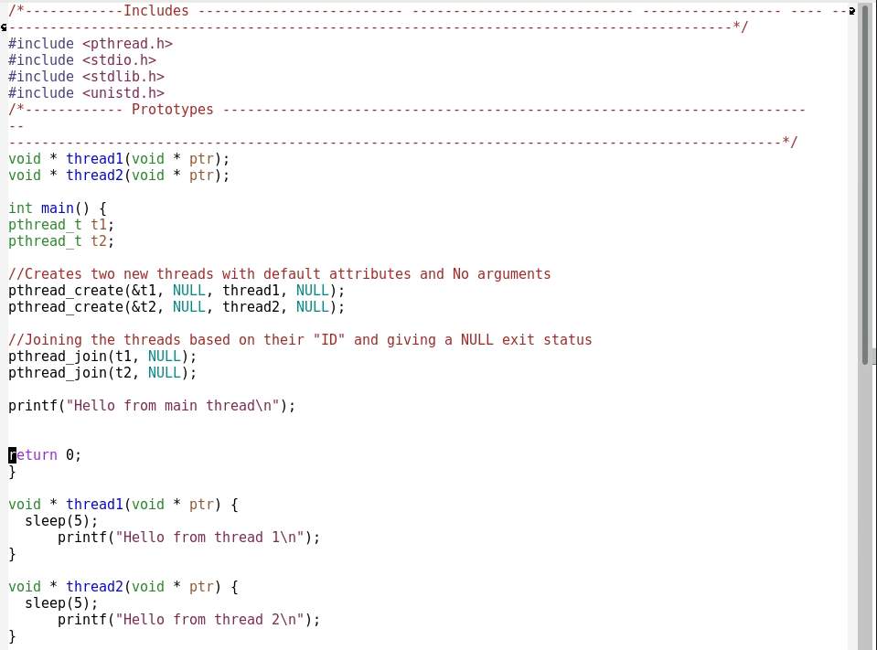

3.2:
3.2.1:
5 pts Compile and run t1.c. What is the output value of v?
V = 0

15 pts Delete the pthread_mutex_lock and pthread_mutex_unlock statements in both increment and decrement threads. Recompile and rerun t1.c. What is the output value of v? Explain why the output is either the same as, or different than, before.
V = -990 or 990, this is different from before because both threads are operating in the critical section at the same time. V values start at zero and in increment and decrement where they loop 99 times adding or subtracting 10 from the current v. At the end of the loop, it will set either -990 or 990 to v. Depending on which run ones “last” will determine the value of v

3.2.2:
20 pts Include your modified code with comments labeling what you added or changed.
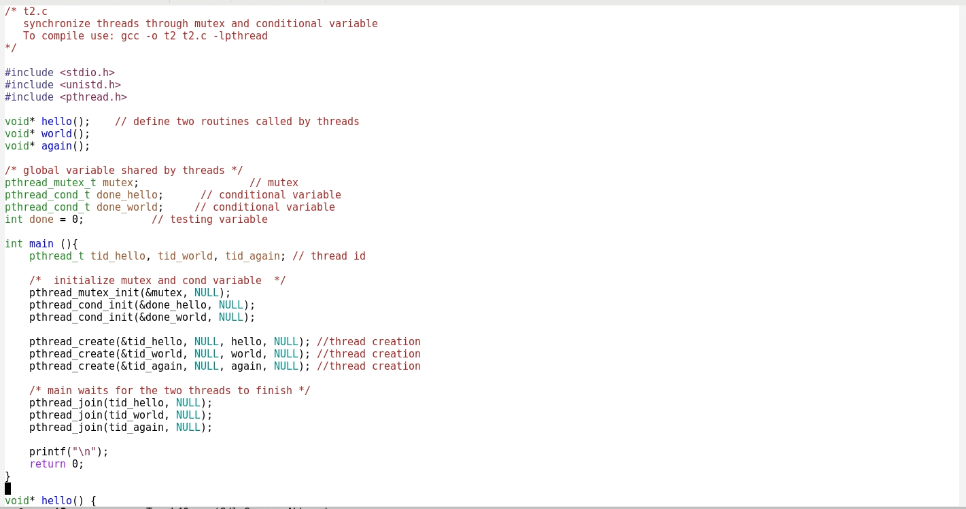
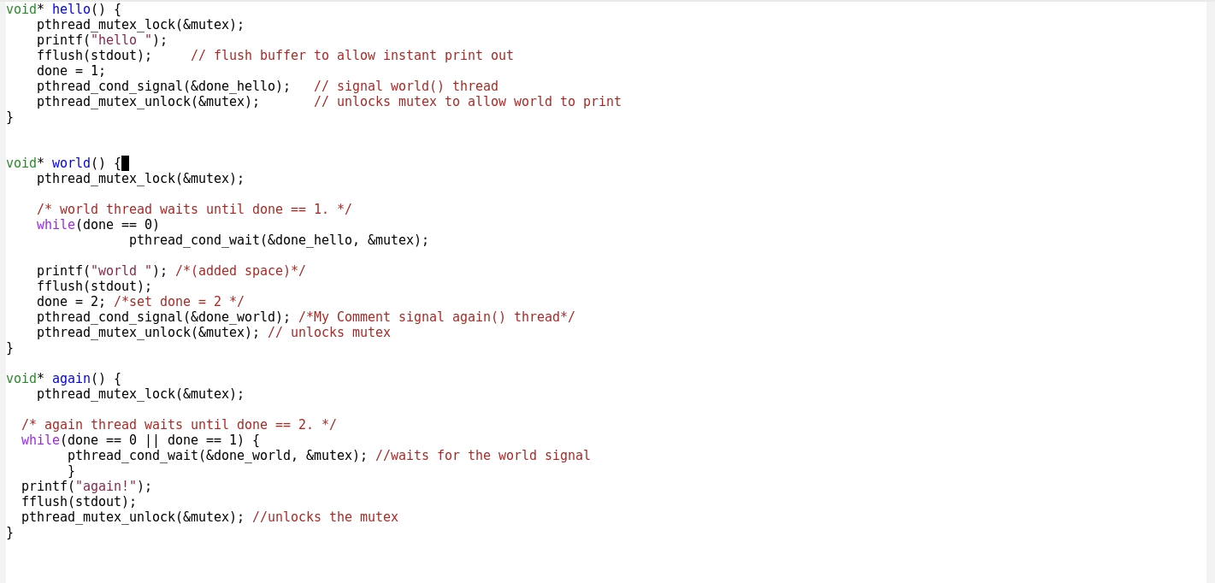

3.3:
20pts Include your modified code with comments labeling what you added or changed.
